Memory allocation

PRACTICAL 8

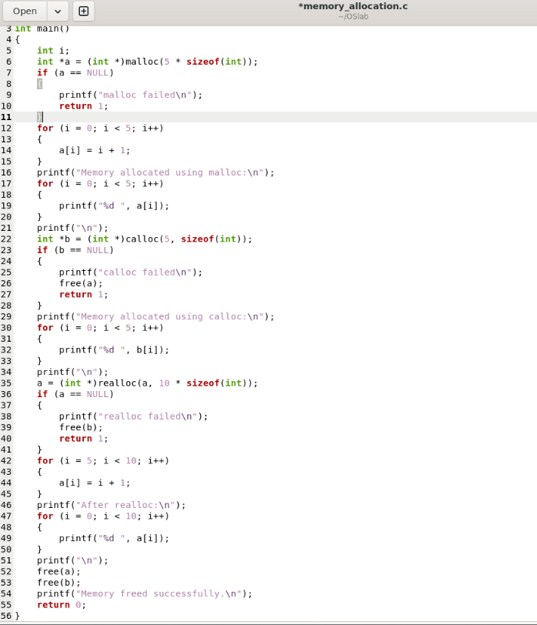

#include <stdio.h> #include <stdlib.h> int main() { int i;
// malloc()
int *a = (int *)malloc(5 * sizeof(int));

if (a == NULL)
{
printf("malloc failed\n"); return 1;
}

for (i = 0; i < 5; i++)
{
a[i] = i + 1;
}

printf("Memory allocated using malloc:\n"); for (i = 0; i < 5; i++)
{
printf("%d ", a[i]);
}
printf("\n");

// calloc()
int *b = (int *)calloc(5, sizeof(int));

if (b == NULL)
{
printf("calloc failed\n"); free(a);
return 1;
}

printf("Memory allocated using calloc:\n"); for (i = 0; i < 5; i++)
{
printf("%d ", b[i]);
}

printf("\n");

// realloc()
a = (int *)realloc(a, 10 * sizeof(int));

if (a == NULL)
{
printf("realloc failed\n"); free(b);
return 1;
}

for (i = 5; i < 10; i++)
{
a[i] = i + 1;
}

printf("After realloc:\n"); for (i = 0; i < 10; i++)
{
printf("%d ", a[i]);
}
printf("\n"); free(a);
free(b);
printf("Memory freed successfully.\n"); return 0;
}

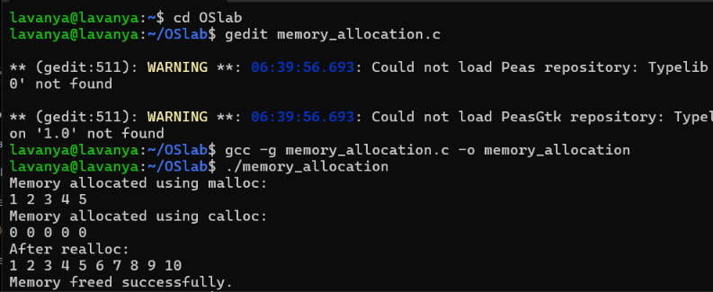

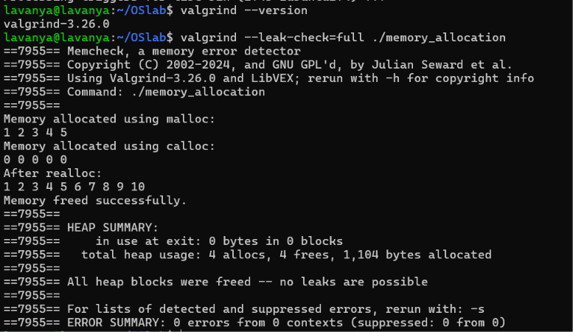

Copy on write
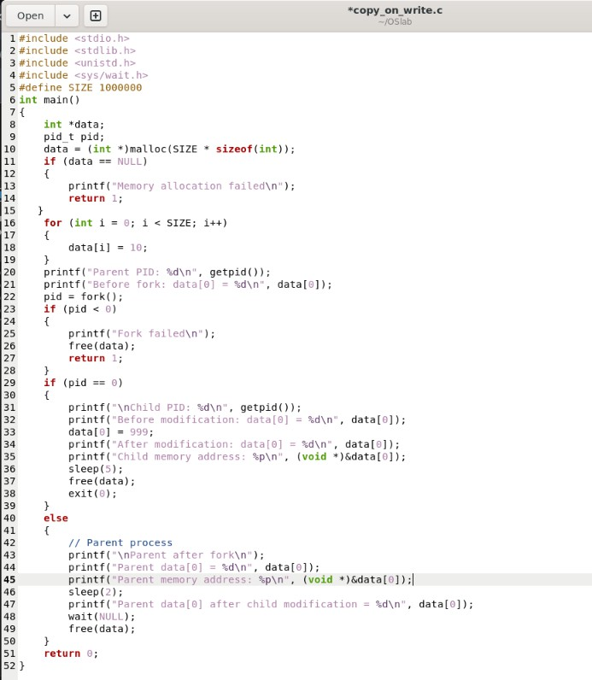

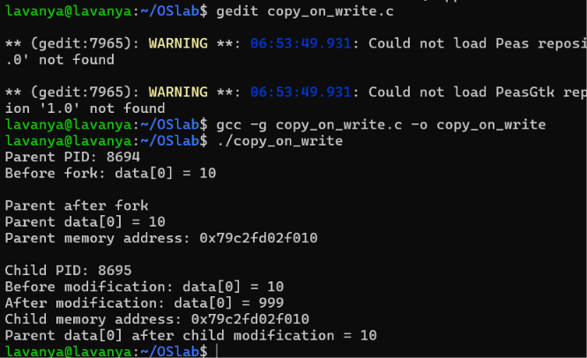

#include <stdio.h> #include <stdlib.h> #include <unistd.h> #include <sys/wait.h> #define SIZE 1000000
int main() { int *data; pid_t pid;

// Allocate memory
data = (int *)malloc(SIZE * sizeof(int));

if (data == NULL)
{
printf("Memory allocation failed\n"); return 1;
}

// Initialize data
for (int i = 0; i < SIZE; i++)
{
data[i] = 10;
}

printf("Parent PID: %d\n", getpid()); printf("Before fork: data[0] = %d\n", data[0]);

pid = fork();

if (pid < 0)
{
printf("Fork failed\n"); free(data);
return 1;
}

if (pid == 0)
{
// Child process
printf("\nChild PID: %d\n", getpid());

printf("Before modification: data[0] = %d\n", data[0]);

// Modify data data[0] = 999;

printf("After modification: data[0] = %d\n", data[0]); printf("Child memory address: %p\n", (void *)&data[0]); sleep(5);
free(data); exit(0);
}
else
{
// Parent process printf("\nParent after fork\n");
printf("Parent data[0] = %d\n", data[0]);
printf("Parent memory address: %p\n", (void *)&data[0]); sleep(2);
printf("Parent data[0] after child modification = %d\n", data[0]);

wait(NULL);

free(data);
}

return 0;

}

